CLIPPING DE NOTÍCIAS – RIO INNOVATION WEEK
Fonte: https://www.instagram.com/p/DbybGKHDlE4/
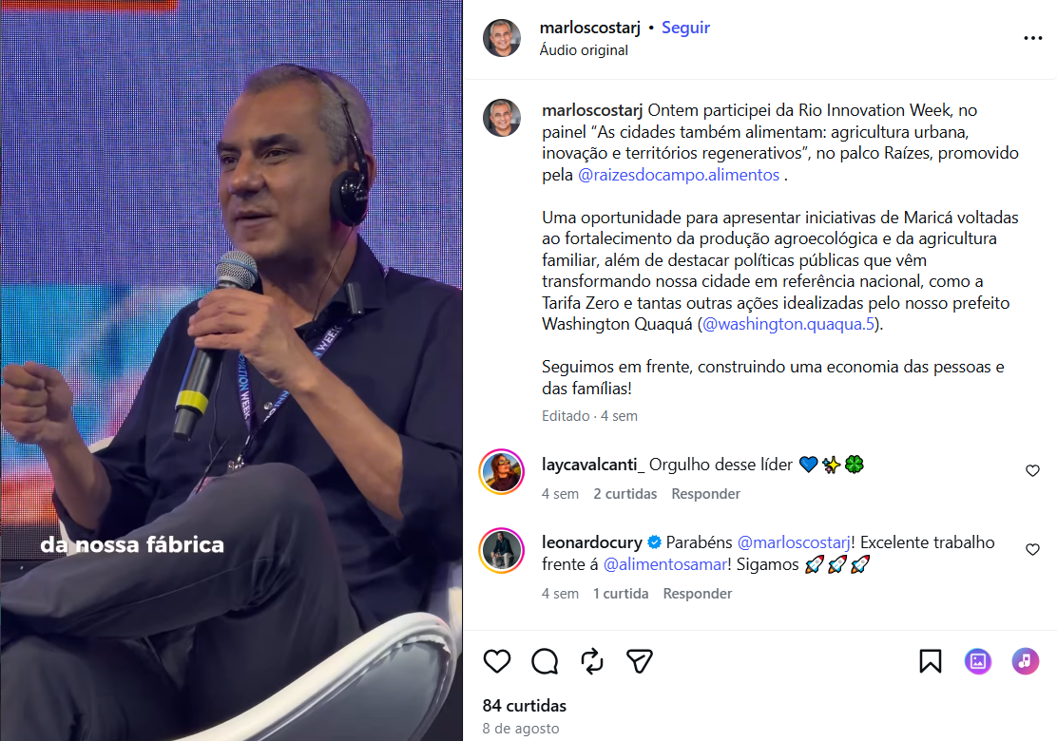

Fonte: https://www.instagram.com/p/Dbx3m6WRjL6/
